North Carolina Central University
School of Library and Information Sciences
Research Colloquium Series Presents
Dr. Noah Lenstra, PhD
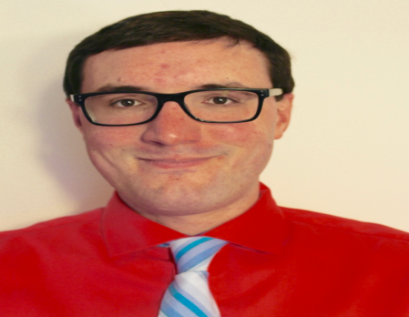
Public Libraries as Health Partners: Programs and Services on Health and Physical Literacy
Wednesday, February 14, 2018
364 James E. Shepard Memorial Library
4:00 - 5:00 pm
Dr. Noah Lenstra, PhD, will be sharing information on how public libraries in the U.S. and Canada support public health through community partnerships. In the U.S. there are 16,536 public libraries, and with recent and ongoing changes in how people access information this ubiquitous social infrastructure has begun to change. Data from the Public Library Association show that between FY2012 and FY2016 attendance at public library programs in the U.S. increased by 27.5% This finding illustrates how people use public libraries differently than they have in the past. They come to attend and participate in programs, many of which form out of community partnerships. This talk begins with the current state of research on how public libraries contribute to public health. Much of this research focuses on consumer health information services, or how public librarians help answer questions related to health. Dr. Lenstra’s research suggests that we do not know enough about other ways that public libraries contribute to heath, namely through the rise of health programming in libraries, which includes things like yoga and tai chi classes, among many others. Based on two studies -- a survey of 1622 public librarians in the U.S. and Canada and a series of in-depth interviews with 37 North Carolina public librarians -- Dr. Lenstra discusses what health programs public libraries currently offer, what community partnerships undergird these programs, and what impacts these programs have, in terms of physical and health literacies. The talk concludes with an interactive discussion about how health informatics scholars and practitioners can best work with public librarians to powerfully contribute to public health outcomes. Live streaming broadcast will be available from Duke University.

Dr. Noah Lenstra, PhD and MLIS, is an Assistant Professor of Library and Information Studies in the School of Education at the UNC-Greensboro, where is also an Affiliated Faculty member in the Gerontology Department. Dr. Lenstra studied at the School of Information Sciences at the University of Illinois, completing his Ph.D. in 2016. He currently serves on Advisory Board for the Public Library Association’s Initiative to Advance Health Literacy and Consumer Health Information in Public Libraries, an initiative funded by National Network of Libraries of Medicine, a unit of the NIH’s National Library of Medicine. His current research focuses on how public libraries support public health through programming and partnerships. He has co-authored “Health Literacy and Physical Literacy: Public Library Practices, Challenges, and Opportunities,” for the 2018 ALISE Conference and to be described in upcoming publications. More information on Dr. Lenstra’s background and work can be found on his website: http://www.noahlenstra.com/.

A reception will follow the presentation in the SLIS Student Lounge, Room 339, Shepard. If you have any questions, please contact: Dr. Deborah Swain (919-530-5702) or Dr. Joseph Meloche (919-530-7322) in the School of Library and Information Sciences.

