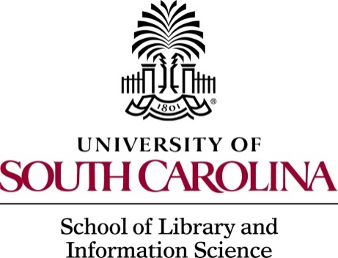

The University of South Carolina School of Library and Information Science in Columbia invites applications for a non-tenure track instructor position.

Shape the future of library and information science. Pursue your interests in a diverse, intellectually stimulating, and multi-disciplinary environment that provides support and encouragement as part of a collaborative work culture. Those with an earned master in library and information science, information technology, or a related field are encouraged to apply. This position requires experience and enthusiasm for teaching in both online and face-to-face formats. Non-tenure track faculty at The University of South Carolina are engaged in instruction, service, administration, and research.

The School is particularly interested in candidates with a specialization in one or more of the following:

- Young Adult Services
- Digital Literacy
- Children’s and Teen Literature
- School Libraries

Selected candidates will be expected to help with the school's commitment to diversity through research, teaching, and service.

The School of Library and Information Science has a growing Bachelor of Science in Information Science program and a joint Certificate of Health Communications with Public Health and Communication. The School's MLIS degree program is fully accredited by the American Library Association. The school library preparation program is part of the University's Professional Education Unit, which is accredited by the Council for the Accreditation of Educator Preparation (CAEP). The School also offers three programs of advanced study beyond the Master's degree (the Certificate of Advanced Graduate Study in Library and Information Science, the Specialist in Library and Information Science, and the Ph.D. in Library and Information Science).

The School has a strong commitment to distance education and is one of two Schools in the College of Information and Communications. The second is the School of Journalism and Mass Communications. The School is located on the campus' historic Horseshoe. It has nationally recognized programs in school library media, youth services, and medical librarianship. Since its inception, the School has emphasized the use of information technology as a vital component of library and information services.

Founded in 1801, the University of South Carolina-Columbia is the flagship campus of an eight-campus, fully accredited, state-supported system. USC­ Columbia has strong undergraduate and graduate programs and other highly regarded professional schools including medicine, law, education, engineering, social work, pharmacy, public health, arts and sciences, nursing, and business administration. The University is a Carnegie Research I institution. Approximately 34,500 students are enrolled on the Columbia campus and more than 50,000 throughout the system. The City of Columbia is the state capital with a metropolitan area population of over 800,000. It is a state center of financial, transportation, and industrial development, and it has a rich historical and cultural tradition. It is located within easy driving distance of both mountains and coast.

Responsibilities:

- Instruct undergraduate and graduate courses in both face-to-face as well as online environments
- Remain current in developments and trends in subject and research areas
- Mentor and advise undergraduate and graduate students
- Support the mission of the South Carolina Center for Children’s Books and Literacy including Cocky’s Reading Express, this could include fundraising and grant writing
- Provide service to the department, college, university, profession, and community

Minimum Qualifications:

- Masters in library and information science, information technology, or a related field is required and are encouraged to apply
- Ability to teach at the undergraduate and graduate level
- Knowledge in creating educational materials for face-to-face and online instruction

Preferred Qualifications:

- Teaching experience at the collegiate level
- Teaching experience in an online or distance education environment
- Experience in management, development, or fund raising

Applications and nominations are invited for this position available in August
2018 or earlier. Salary is fully competitive. The Committee will begin full review of applications and nominations on December 4, 2017 and will continue until the position is filled.

To apply, please use this link: http://uscjobs.sc.edu/postings/19567
Application materials include:
1) A letter of application that addresses stated responsibilities and qualifications
2) Current vitae
3) List of three references

For further information, questions, or to submit nominations, send an email to Dr. Dick Kawooya, Committee Chair, at kawooya@sc.edu or call at 803-777-4949 or Mike Corbo, Office and Communication Coordinator, at mcorbo@email.sc.edu, 803-777-3858.

School Information is available at http://www.sc.edu/study/colleges_schools/cic/library_and_information_science

The University of South Carolina is committed to diversity. We are an equal opportunity employer and committed to
continuing to develop a more diverse faculty, staff, student body and curriculum.

